AI-Driven EV Charging & Mobility: An Exploratory Data Analysis
Interactive Business Intelligence Dashboard using Python and Power BI
- Project Overview and Objective
Project Overview
This project analyses EV charging infrastructure performance, usage behaviours, and revenue streams across South India to help operators optimize station efficiency and pricing models.
- Dataset Scale: Analyses 27,234 charging sessions across 6 South Indian states/UTs (Tamil Nadu, Kerala, Karnataka, Telangana, Andhra Pradesh, Puducherry) and 37 major cities.
- Energy & Revenue Impact: Evaluates over 719,344 kWh of energy delivered, driving $300,380 in total session revenue across both AC and DC charging networks.
- Charger Utilization: Highlights high demand for AC slow charging (21,235 sessions) alongside faster, high-yield DC fast charging (5,999 sessions).
Project Objective
- Analyse Charging Behaviour: Evaluate session durations, energy consumption patterns, and idle times across AC and DC charging networks to understand user charging habits.
- Optimize Revenue & Tariff Models: Assess revenue generation (Session Total) across different vehicle categories, tariff types, and charging price rates to identify profitable CPO models.
- Identify Regional & Infrastructure Demand: Map charging demand and operational status across states, major cities, and location areas to highlight key high-demand hubs and coverage gaps.
- Assess Vehicle & Battery Utilization: Examine energy delivery trends across 2-Wheeler and 4-Wheeler battery capacities and state-of-charge ranges (SOC_Start_% vs. SOC_End_%).
- To generate actionable insights for EV charging infrastructure planning by identifying high-demand locations, availability gaps, pricing patterns, and opportunities for better charging-station management.

- Data Sources

- Source Description and Timeline: Real-time primary data collected directly from Rebolt EV charging stations in Bengaluru communities. https://www.reboltnetwork.com/

- Year / Timeline: Data collected during 2026

- Domain: Electric Vehicle (EV) Charging, Smart Mobility Analytics

- Problem Statement

- Identify EV charging demand patterns and trends
- Analyse energy consumption and charging duration
- Understand customer charging behaviour
- Analyse charging cost and payment behaviour
- Identify frequently used connector types
- Compare charging activity across different locations
- Identify peak and low charging periods
- Detect missing values, duplicates, and data-quality issues
- Generate meaningful insights using Python EDA
- Develop an interactive Power BI dashboard for decision-making

- Attribute (Column /Features) Details:
Column Name | Data Type | Description
EV_charge_stationname | Text (String) | Name of the EV charging station.
Charge_locationid | Text (String) | Unique identification code for the charging location.
EV_station_workstatus | Text (String) | Operational status of the station (e.g., Available, Temp Closed).
City_Name | Text (String) | City where the charging station is located.
Location_Area_Name | Text (String) | Specific neighbourhood or area name of the station.
CPO_Operator | Text (String) | Charge Point Operator managing the network (e.g., Rebolt, Ather Grid).
Vehicle_Name | Text (String) | Model or identifier of the electric vehicle being charged.
Vehicle_Category | Text (String) | Category of the vehicle (e.g., 2-Wheeler, 4-Wheeler).
Session_ID | Text (String) | Unique transaction ID assigned to each charging session.
Charger_Type | Text (String) | Type of charger used (AC slow charging or DC fast charging).
Charging_Mode | Text (String) | Technical charging mode/protocol used during the session.
Charger_Power | Text (String) | Power output capacity rating of the charger.
Connector_Type | Text (String) | Type of plug/connector attached to the vehicle.
Connector_Code | Text (String) | Specific code or port designation for the connector.
Currency | Text (String) | Currency used for billing transactions.
Price_per_kWh | Float (Numerical) | Cost charged to the user per kilowatt-hour of energy consumed.
Session_Start_Datetime | Text (String) | Timestamp recording when the charging session began.
Session_End_Datetime | Text (String) | Timestamp recording when the charging session completed.
Duration | Text (String) | Total duration of the charging session (formatted HH:MM:SS).
Duration_Minutes | integer | Total duration of the session converted into minutes.
Energy_Qty_kWh | Float (Numerical) | Total electricity transferred to the vehicle in kilowatt-hours.
Vehicle_Make_Model | Text (String) | Manufacturer make and specific model of the EV.
Vehicle_Type | Text (String) | Specific classification or body type of the vehicle.
Vehicle_Battery_kWh | Float (Numerical) | Total battery capacity of the vehicle in kilowatt-hours.
SOC_Start_% | integer | State of Charge (battery percentage) at session start.
SOC_End_% | integer | State of Charge (battery percentage) at session end.
Payment_Method | Text (String) | Payment method used (e.g., UPI, Credit Card, Wallet).
Payment_Status | Text (String) | Transaction status of the payment (e.g., Completed, Failed).
Session_Energy_Amount | Float (Numerical) | Base monetary cost for the total energy consumed.
Float (Numerical) | Float (Numerical) | Fixed fee charged for initiating or hosting the session.
Untaxed_Amount | Float (Numerical) | Subtotal cost before taxes are applied.
Tax_Rate_% | integer | Applicable tax rate percentage.
Tax_Amount | Float (Numerical) | Calculated tax amount for the session.
Session_Total | Float (Numerical) | Final total amount billed to the user including taxes and fees.
Meter_Start_kWh | Float (Numerical) | Electricity meter reading at the start of the session.
Meter_End_kWh | Float (Numerical) | Electricity meter reading at the end of the session.
Session_Status | Text (String) | Outcome status of the session (e.g., Completed, Interrupted).
Idle_Time_Minutes | integer | Minutes vehicle stayed plugged in after reaching full charge.
Tariff_Type | Text (String) | Pricing structure applied (e.g., Energy, Time + Energy).
Date | Text (String) | Start date of the charging session.
Time | Text (String) | Start time of the charging session.
E_Date | Text (String) | End date of the charging session.
E_Time | Text (String) | End time of the charging session.
Session_Code | integer | Numeric reference code associated with the session.
State | Text (String) | State/UT where the station is located.

- Tools & Technologies
Python:
- Pandas – Manipulating tabular data and structured workflows
- NumPy – Performing numerical operations and array processing
- Seaborn & Matplotlib – Building statistical charts and custom graphics
- Data Processing – Handling nulls, type conversion, and duplicate checks
- Exploratory Data Analysis – Uncovering feature distributions and trends
Power BI:
  - Power Query – Data transformation and schema validation
  - DAX – Dynamic measures, ratios, and summary metrics
  - Dashboard Design – Interactive cross-filtering, heatmaps, and metric cards
  - Performance Tracking – Location, revenue, and charger utilization monitoring
- Data Pre-Processing
Data Cleaning:
- Checked and corrected data types.
- Handled missing values using mean and mode filling.
- Detected and removed duplicate session records.
- Removed extreme outliers from charging duration and idle time.
Data Transformation:
- Split datetime fields into separate date, time, and peak-hour metrics.
- Cleaned and standardized text formatting across station and location names.
- Prepared and exported the clean dataset directly to Power BI.
Data Visualization (Python):
- Distribution of Charger Types: Plotted bar charts comparing AC slow chargers vs. DC fast chargers.
- Session Idle Time: Generated boxplots to identify outliers and analyse post-charge idle minutes.
- Energy Consumption: Visualized total energy delivered (kWh) across sessions using histograms.
- Peak Demand Hours: Built line charts tracking hourly charging sessions across different times of day.
- Location Performance: Created bar plots comparing energy throughput and revenue across station areas.
- Correlation Analysis: Generated heatmaps to analyse relationships between charging duration, cost, and energy transferred.

- Data Visualization
Bar Chart
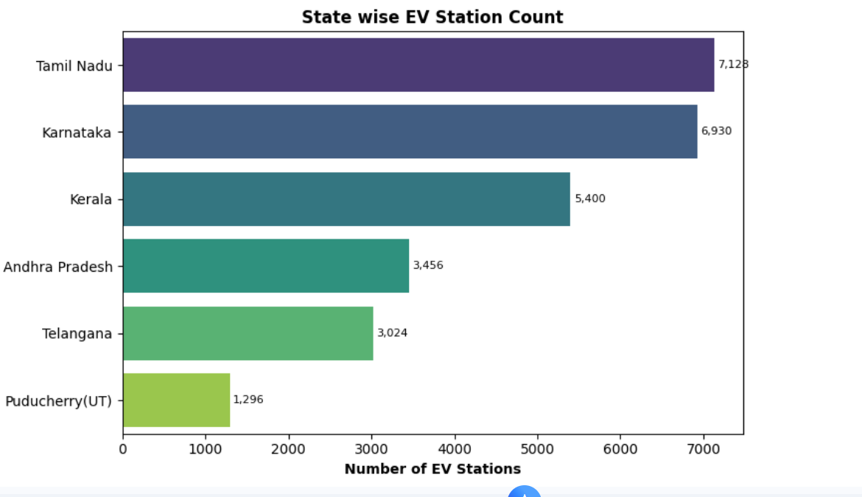
Analytical interpretation
- Dominant Southern Hubs: Tamil Nadu leads network distribution with 7,128 EV stations, followed closely by Karnataka with 6,930 stations. Together, these two states account for 51.6% (14,058) of the entire regional network.
- Tiered Geographic Distribution:
- Leader Tier (>6,000): Tamil Nadu & Karnataka
- Mid Tier (3,000–5,500): Kerala (5,400), Andhra Pradesh (3,456), and Telangana (3,024)
- Emerging/UT Tier (<1,500): Puducherry (UT) with 1,296 stations
- Geographic Scale Ratio: Tamil Nadu has 5.5 times more EV stations than Puducherry (UT).
- Strategic Takeaway: Infrastructure investment is heavily concentrated in manufacturing and tech corridors (Tamil Nadu & Karnataka), while mid-tier states present strong potential expansion zones for expanding coverage.
Bar Chart (Vertical)
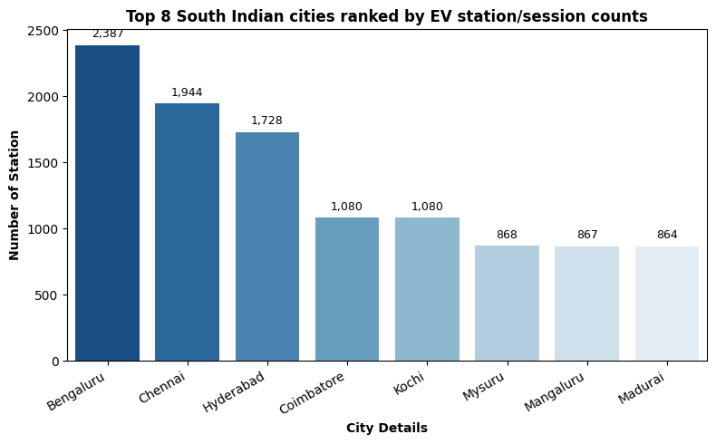
Analytical interpretation
- Top Metro Dominance: Bengaluru leads the region with 2,387 EV stations, followed by Chennai (1,944) and Hyderabad (1,728). Together, these top 3 metro hubs represent 56.0% (6,059) of the total station count across all top 8 cities.
- Tier-2 Operational Parity: Coimbatore and Kochi hold identical network scales with 1,080 stations each, acting as strong secondary charging hubs.
- Balanced Regional Cluster: Mysuru (868), Mangaluru (867), and Madurai (864) share nearly identical station counts, forming a stable baseline for secondary city infrastructure.
- Network Concentration: Bengaluru has 2.76 times as many EV stations as Madurai, highlighting a heavy concentration of infrastructure in major tech hubs compared to tier-2 urban centres.

Pie Chart
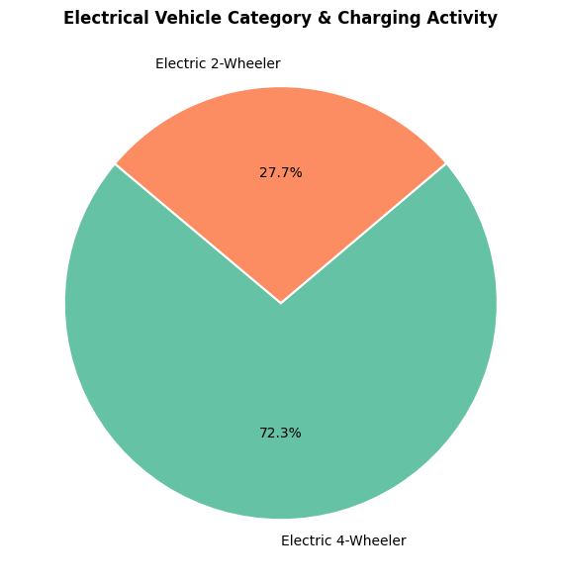
Analytical interpretation
- 4-Wheeler Dominance: Electric 4-Wheelers dominate network charging activity, accounting for 72.3% of total usage.
- Secondary Share: Electric 2-Wheelers represent the remaining 27.7% of charging activity.
- Demand Ratio: Electric 4-Wheelers generate 2.61 times the charging volume/activity compared to Electric 2-Wheelers.
- Strategic Implication: Infrastructure planning should prioritize high-capacity fast chargers tailored for 4-wheelers to match the overwhelming primary demand, while dedicating targeted slow/standard charging points for 2-wheelers.
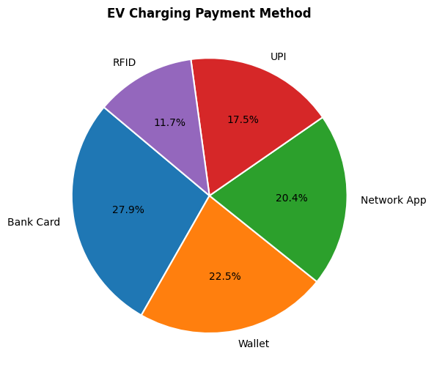
Analytical interpretation
- Primary Payment Channel: Bank Card is the single most preferred payment method, accounting for 27.9% of total EV charging transactions.
- Mobile & Digital App Dominance: Mobile-first digital payment channels (Wallet at 22.5%, Network App at 20.4%, and UPI at 17.5%) collectively command a 60.4% majority share of all transactions.
- Niche Adoption: RFID card payments record the lowest usage at 11.7%, showing a 2.38x preference for direct Bank Cards over physical RFID tokens.
- Strategic Takeaway: Payment gateways must maintain seamless integration with digital wallets, network app balances, and instant UPI checkout pathways while supporting standard debit/credit card infrastructure.
Histogram Chart
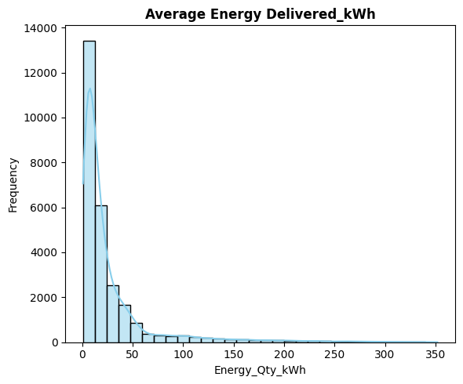

Analytical interpretation
- Low Energy Focus: Most charging sessions use low to medium amounts of energy.
- Main Usage (0–25 kWh): Most charges use 0 to 25 kWh, peaking over 13,000 sessions. This fits quick daily top-ups for 2-wheelers and city cars.
- Quick Drop-Off: Sessions using over 50 kWh drop sharply to under 1,000 instances.
- High-Energy Tail (100–350 kWh): Rare sessions reach up to 350 kWh. These come from buses, commercial fleets, or heavy-duty vehicles.
- Key Takeaway: Stations should focus on fast availability for <30 kWh charges, while planning the power grid for occasional high-demand surges over 200 kWh.
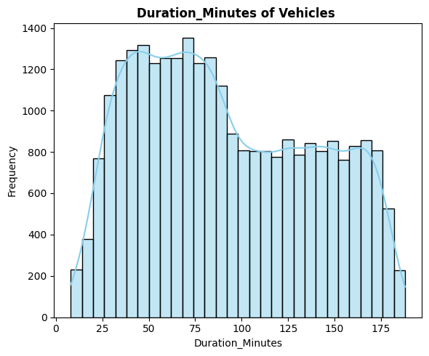

Analytical interpretation
- Two Peak Times: Charging sessions show two main groups of users behaviour.
- Main Peak (35–85 Mins): Most sessions last 35 to 85 minutes, peaking around 70–75 minutes. This shows fast-charging top-ups.
- Second Peak (100–170 Mins): A smaller group stays connected for 100 to 170 minutes. This shows slow charging or vehicles remaining parked.
- Time Limits: Very few sessions last under 20 minutes or over 180 minutes.
- Action Item: CPOs can add extra fees for sessions over 90 minutes to keep fast chargers available.
Boxplot
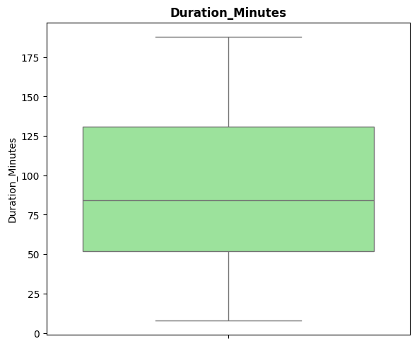
Analytical interpretation
- Median (Q2): Half of the charging sessions take under 84 minutes, and half take longer.
- First Quartile (Q1):25% of all sessions finish within 52 minutes.
- Third Quartile (Q3):75% of all sessions finish within 131 minutes.
- Interquartile Range (IQR): The middle 50% of charging sessions last between 52 and 131 minutes.
- Minimum Duration: The shortest sessions recorded are around 8 minutes.
- Maximum Duration: The longest sessions recorded reach around 188 minutes.
- Symmetry: The durations are evenly spread with no extreme outlier sessions.
Grouped Bar Chart
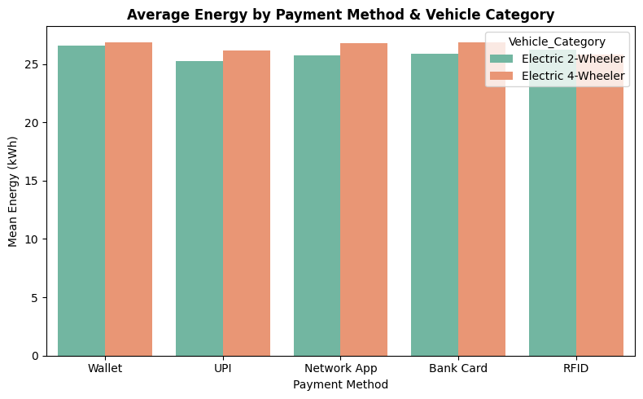
Analytical interpretation
- Tamil Nadu and Karnataka have the most EV charging stations.
- Bengaluru is the top city for charging station count.
- 4-Wheelers make up most of the charging activity.
- Bank Cards and Mobile Apps are the main payment choices.
- Most vehicles charge for 35 to 85 minutes per session.
- Drivers use about 25 to 27 kWh of energy per charge.
Scatterplot Chart
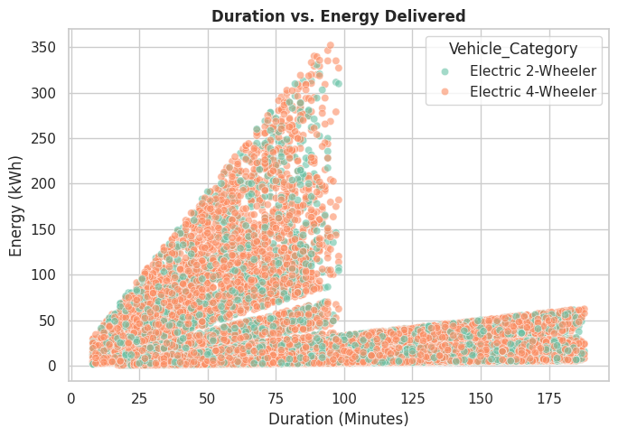
Analytical interpretation
- Direct Link: Longer charging time gives more energy, up to around 100 minutes.
- Fast Chargers (0–100 Mins): High energy flow (up to 350 kWh) happens in sessions under 100 minutes, showing fast DC charging.
- Slow Chargers (100–180 Mins): Sessions past 100 minutes stay low in energy (under 60 kWh), showing slow AC charging or parked vehicles.
- Vehicle Types: Both 2-Wheelers and 4-Wheelers follow the same charging speed patterns across all durations
Comparative Boxplot
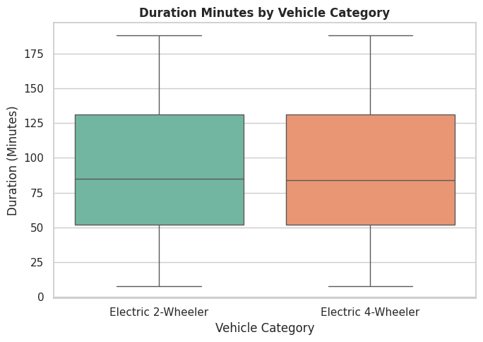
Analytical interpretation
- Nearly Identical Behavior: Electric 2-Wheelers and Electric 4-Wheelers spend almost the exact same amount of time connected at charging stations.
- Equal Average Time: Both vehicle types have a median charging duration of about 84 minutes.
- Same Typical Range: For both categories, the middle 50% of sessions last between ~52 minutes and ~131 minutes.
- Same Limits: Shortest sessions start around 8 minutes, while longest sessions cap out near 188 minutes for both vehicle groups.
- Key Takeaway: Vehicle type does not affect how long drivers stay plugged in—time spent depends entirely on charger speed, not vehicle size.
Multivartity Pairplot

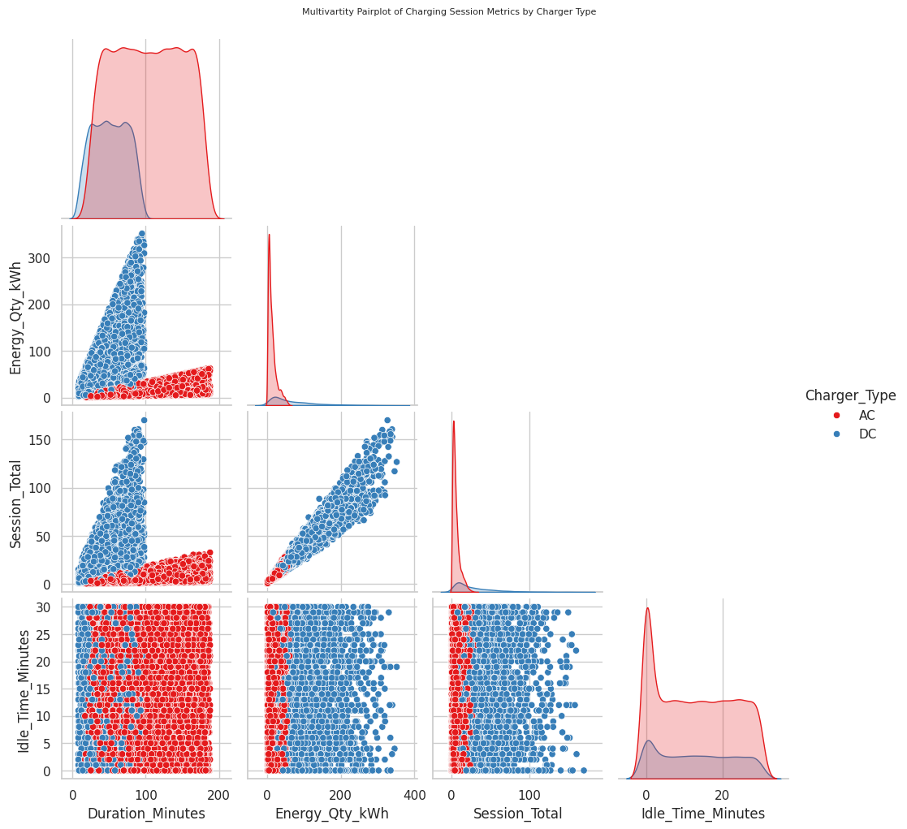

Analytical interpretation
- DC Chargers Deliver Far More Energy: DC chargers (blue) reach up to 350 kWh, while AC chargers (red) stay capped below 60 kWh.
- DC Chargers Earn Higher Revenue: Total session cost scales steeply with DC fast chargers due to higher power delivery, whereas AC sessions remain low-cost.
- AC Chargers Take Longer for Less Power: AC sessions spread across full durations up to 200 minutes while delivering minimal energy.
- Idle Time Impacts Both Charger Types: Idle time spans evenly from 0 to 30 minutes across both AC and DC chargers, showing drivers leave vehicles plugged in regardless of charging speed.
- Key Takeaway: DC chargers drive network energy throughput and revenue, while AC chargers tie up station plugs for long periods at lower delivery rates

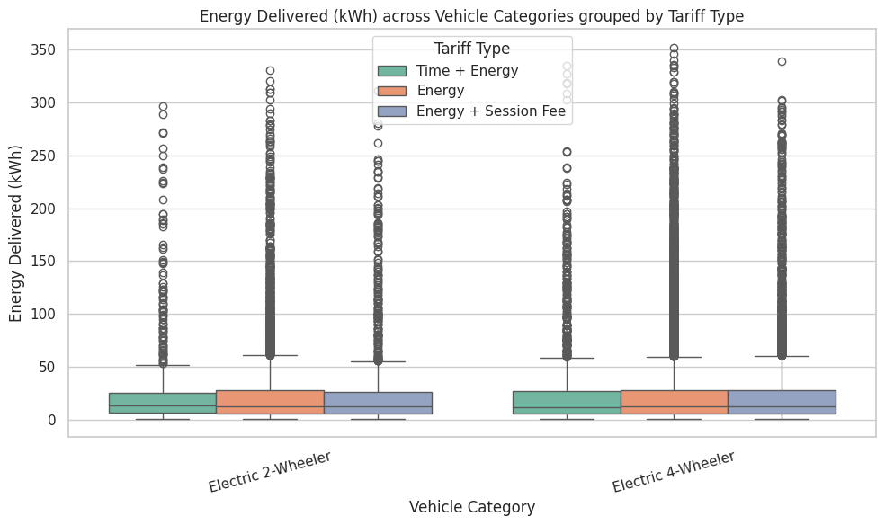
Analytical interpretation
- Same Normal Usage: Drivers take about 10 to 15 kWh of energy per charge, no matter which pricing plan they choose.
- No Change in Behavior: Switching tariff types does not change how much energy drivers buy.
- Extreme Users: A few large sessions still draw up to 350 kWh under every pricing plan.
- Key Takeaway: Pick tariff plans to improve business profits and station turnover, not to control energy usage.

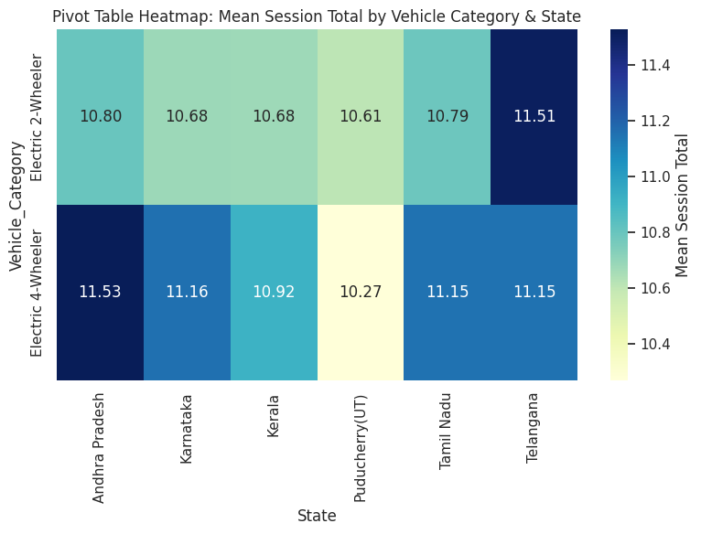
Analytical interpretation
- 4-Wheelers Earn More: Electric 4-Wheelers make more money per session in most states, leading in Andhra Pradesh at 11.53.
- Telangana Top for 2-Wheelers: Telangana brings in the highest 2-Wheeler earnings at 11.51, slightly beating its 4-Wheeler average (11.15).
- Puducherry Lowest: Puducherry sees the lowest 4-Wheeler earnings at 10.27, making it the only place where 2-Wheelers earn more (10.61).
- Steady Income Elsewhere: States like Karnataka and Tamil Nadu stay steady between 10.68 and 11.16 for both vehicle types.
- Key Takeaway: Revenue stays flat and predictable across South India, with 4-Wheelers driving slightly higher totals overall.

- Data Modelling and DAX (Power BI)
Track revenue generation, station operational efficiency, and overall network utilization across cities and locations.
KPI Cards
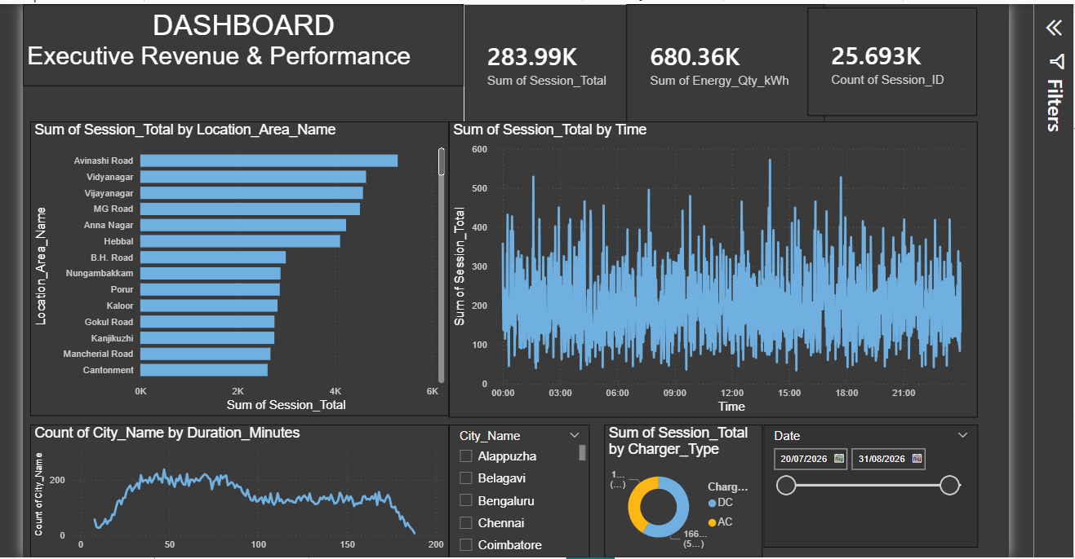
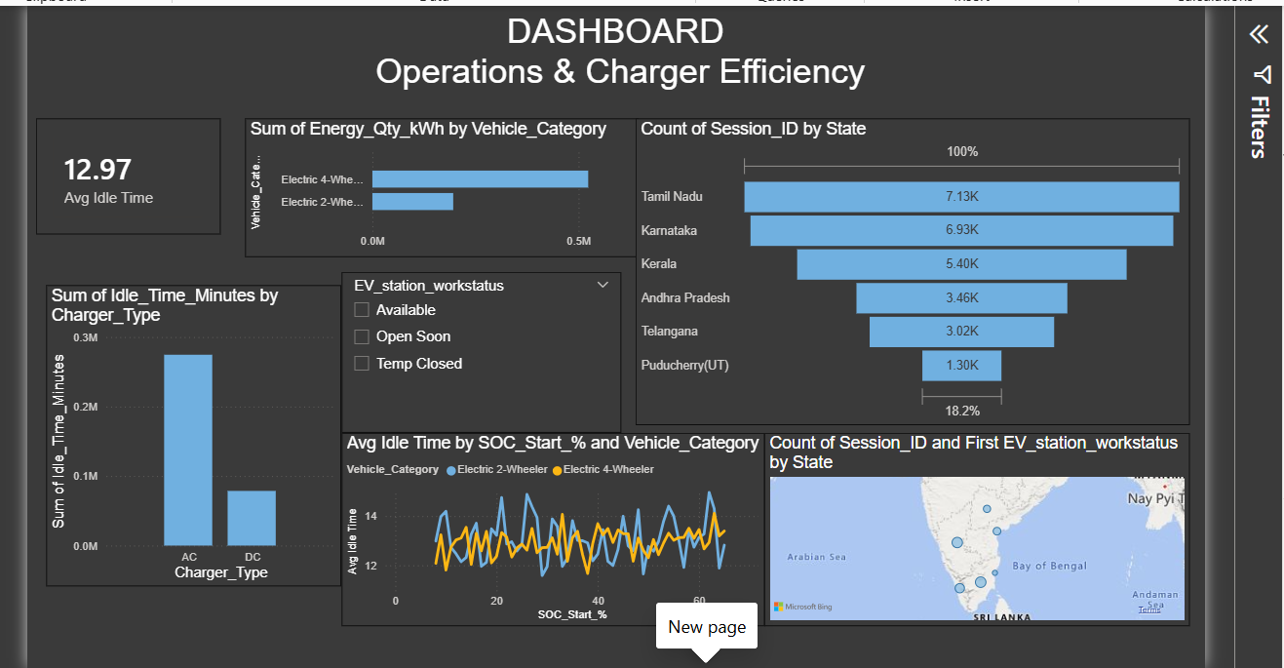

- Insights & Conclusions
Key Findings:
- Big Cities Lead: Bengaluru, Chennai, and Hyderabad have more than half of all charging stations.
- 4-Wheelers Top Usage: Electric 4-Wheelers make up nearly three-fourths of all charging sessions.
- Popular Payments: Most drivers pay using bank cards or mobile apps.
- Charging Time: Most drivers stay connected for 35 to 85 minutes per session.
- Power Used: Most sessions use a small amount of power, between 0 and 25 kWh.
Diagnostic Analysis
- Top Cities: Bengaluru has the most chargers with 2,387 stations, followed by Chennai and Hyderabad.
- Vehicle Breakdown: 4-Wheelers make up 72.3% of all charging, while 2-Wheelers make up 27.7%.
- Payment Choices: Most drivers pay using digital options like apps, wallets, and UPI (60.4%) or bank cards (27.9%).
- Charging Duration: The average session takes about 84 minutes, with half of all sessions lasting between 52 and 131 minutes.
Predictive Analysis (What is likely to happen?)
- More City Demand: Big tech cities like Bengaluru will see higher charger use as more people buy 4-Wheelers.
- Power Grid Stress: Large fleet vehicles using over 200 kWh will cause sudden power spikes on local grids.
- Blocked Chargers: Drivers staying plugged in for over 90 minutes will cause long waits for others looking for open chargers.
Prescriptive Analysis (What should we do?)
- Add More Fast Chargers: Put high-speed DC chargers in busy cities for 4-Wheelers.
- Charge Overstay Fees: Add extra fees when sessions go over 90 minutes so drivers do not hog chargers.
- Make Payments Easy: Focus on quick payments using UPI, wallets, mobile apps, and card readers.
10. Conclusions
- Focus on Fast Charging: Expanding DC fast chargers in major cities will support the growing number of 4-Wheeler users.
- Reduce Station Waiting: Charging extra fees for sessions over 90 minutes will keep chargers open for new drivers.
- Protect the Power Grid: Planning for sudden high-energy draws over 200 kWh will prevent local grid overloads.
- Streamline User Payments: Keeping app, UPI, and card payments fast will improve driver experience at all stations.

